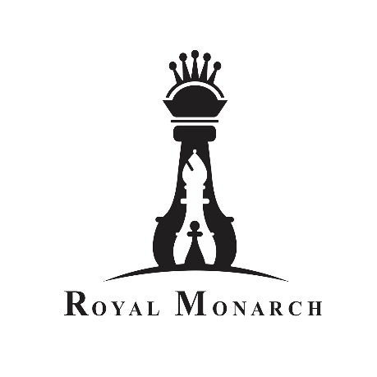

Beware of fraudulent tips and advice on stock market

|  |  |
| --- | --- |
| |  | | --- | | At Royal Monarch, your account security is our priority and we take great measures to ensure the same.  Royal Monarch and its group companies do not offer tips or advice on stock market over the phone. Beware of receiving fraudulent communications, unauthenticated trading tips and unsolicited calls on trading in stocks from unverified sources.  **What should you do if you receive a trading tip over phone or SMS?**   * Please verify the authenticity of the caller, at the slightest doubt, desist from acting on such calls or tips * Ensure you are registered on the TRAI DND. To know more about options for blocking commercial marketing calls, [click here](http://www.nccptrai.gov.in/nccpregistry/Guidelines%20for%20Customer.pdf) * Report any unsolicited stock tip or marketing call to TRAI and your service provider * Android phone users can also download the DND (2.0) App offered by TRAI to register number under DND and report unsolicited commercial communications.  **Stay alert!** | |